Connecting Watershed Efforts in the Kings River Watershed
Concept Overview for the Tulare Basin Watershed Connections Workgroup

January 2015

Kings River Watershed
- Watershed covers 1,850 sq miles
- Wild and Scenic section (65 mile stretch) of Kings River
- Mill Creek is an important tributary of the Kings River
- Water for municipal, agriculture, recreation, warm and cold water fisheries
Managing Entities
Managing entities in the Kings River Watershed include the Army Corps of Engineers, Fresno Metropolitan Flood Control District, Sierra RCD, PG&E, ditch companies, Friends of the Kings River, Kings River Conservation District, Kings River Conservancy, Kings River Water Association, Upper Kings Basin Water Forum (also called Kings Basin Water Authority), and the National Park Service.
Watershed Stressors
There are several watershed issues including water quality degradation after fires, downstream flooding, wildlife connectivity, groundwater availability, quality and management, well yield, county zoning, land use and water quality, and invasive species.
Goals
- Integrate multiple efforts and forge new collaborations to bring partnerships, resources and identify benefits;
- Improve water management in upper watersheds by implementing creative water management projects;
- Provide whole watershed benefits and increase collaboration resulting in in-stream flow, additional water supplies and improved water quality;
- Increase resources for watershed-scale resource management.

Key Components of a Watershed-Scale Restoration Program
- Multi-stakeholder planning and prioritization (e.g. Upper Kings IRWMP and Southern Sierra IRWMP)
- Planning
  - Watershed assessment and watershed management plan for Southern Sierra (using SS IRWMP as guiding planning document)
  - Non-profit or agency grantees with significant interest, track record and capacity
  - EQA and NEPA studies, permitting and processes;
  - Specific project designs and impact analyses;
  - Discussions and negotiations with water right holders, constituents, public, partners, collaborators, etc. to form and integrate projects;
  - Monitoring – project and adaptive management;
  - Funding for all of the above.

- Implementation
  - Non-profit or agency grantees with significant interest, track record and capacity;
  - Effective, experienced project managers and staff;
  - Implementation funding;
  - Funding for monitoring;
  - Construction, design and long-term maintenance funding.

Existing Efforts Currently Underway
- Southern Sierra Regional Water Management Group Kings River Watershed Action Plan
- Kings River IRWMP Implementation
- Kings River Experimental Watershed Research
- UC Merced Watershed-level Hydrological Research
- Dinkey Collaborative
- Rough Fire Water Quality Monitoring
- Mill Flat Creek Riparian Restoration and Road Decommissioning Project
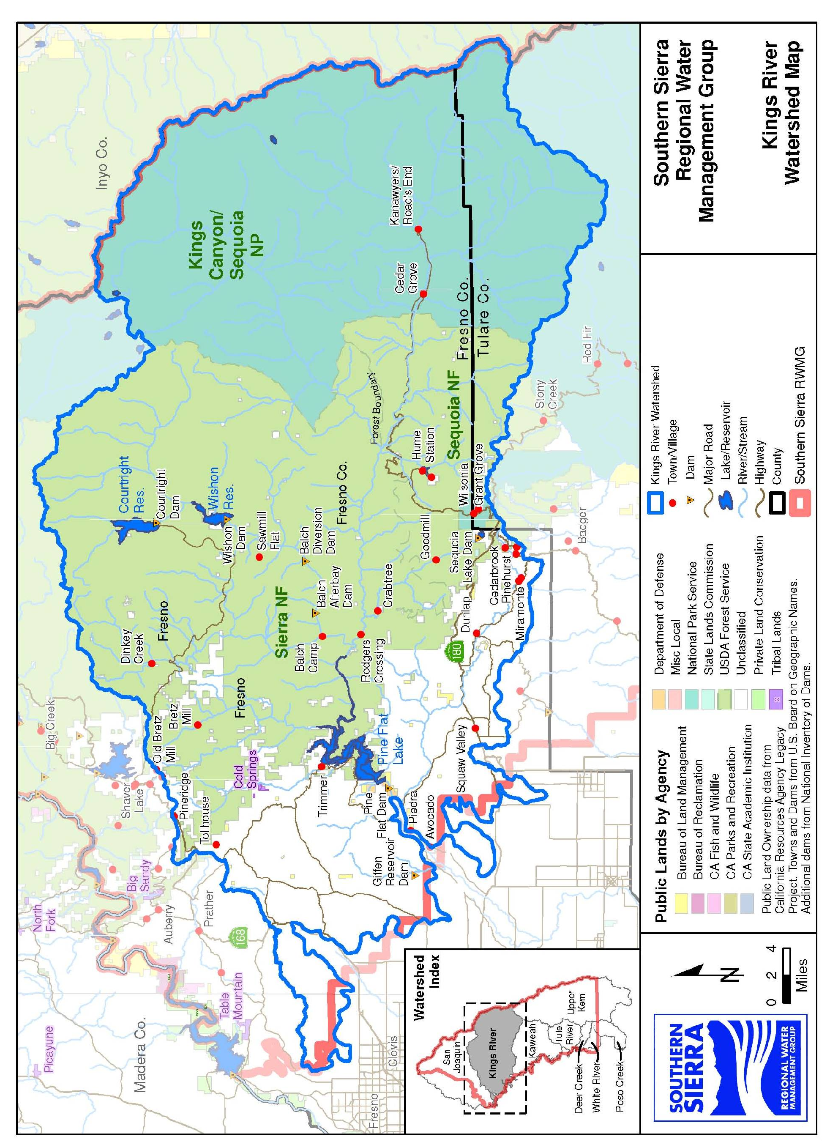
- Sierra and Sequoia National Forest Management Plans

For more information contact: Bobby Kamansky southernsierrairwmp@gmail.com

