Meeting Summary
Allensworth – Alpaugh – Atwell Island Trail Project Community Meeting
February 20, 2016, 10am-1pm

Participants
Alpaugh residents:
Pat Smith
Maria Luisa Garcia
Maria Marez
Ana Molina
Sandra Meraz – Alpaugh Community Advocate

Allensworth residents:
Daisy Calderon
Nettie Morrison
Sherry Hunter
Larry Hutson
Lateef Kadara – artist
Denise Kadara – Allensworth Community Advocate
Kayode Kadara – Allensworth Community Advocate

Agency and Organization Representation:
Ann Williams – Friends of Allensworth
Steve Ptomey – Colonel Allensworth State Historic Park
Jerelyn Oliveira – Colonel Allensworth State Historic Park
Rob Hudson – Alpaugh Unified School District (AUSD)
John Burchard – Alpaugh Community Services District
Jihadda Govan – BLM Atwell Island
Caroline Kilbane – BLM Atwell Island
Angel Avitia – CSET
Terry Schmal – CSET
Mike Fanelli – Dragados Flatiron (HSR rep)
Larry Saslaw – Tulare Basin Wildlife Partners (TBWP
Carole Combs – TBWP
Rob Hansen – TBWP
Dezaraye Bagalayos – TBWP
Karina Alvarez-Liston – College of the Sequoias student
Meeting Opener and Welcome
Rob Hudson – AUSD
Rob Hudson welcomed and expressed gratitude to all in attendance. He opened the meeting giving a short history of his work in both Allensworth and Alpaugh. Before becoming superintendent for AUSD he worked in the Allensworth school and is familiar with both communities and their shared qualities and issues.
Mr. Hudson spoke about the uniqueness of the Tulare Lake Basin landscape and drew attention to the fact that Atwell Island and Alpaugh share one of the only remaining pieces of Tulare Lake shoreline. He added that a community nature trail would highlight that important, unique landmark and increase access to it for area residents and visitors.
“This is the beginning of something great for both communities. If Alpaugh and Allensworth can continue to reconcile themselves to and celebrate their commonality this can be a great moment for us. There is beauty here and we must all take the time to look and pursue projects that showcase its uniqueness and beauty.” - Rob Hudson

Purpose and goals of the community meeting
Jihadda Govan – BLM Atwell Island & Denise Kadara – Allensworth Community Advocate
Background: In a 2013 roundtable discussion, attended by several disadvantaged community representatives from southwest Tulare County, the idea of a nature trail system to connect the communities of Alpaugh and Allensworth and to showcase the unique landmark locations in both communities was proposed. Though the idea was met with great enthusiasm resources to realize such a project were largely absent. Recently support and funding opportunities have become available making it possible to move forward with the trails project.
- Establish a vision for a multi-use recreational nature trail that will connect Allensworth and Alpaugh to two unique and historical attractions in southwest Tulare County
- Map possible trail routes and develop list of potential land and water partners
- Present the idea and benefits of establishing an ongoing Intra-Community Advisory Council comprised of residents from both communities, and take the lead in moving the trails project and future community projects forward.

Area map overview including local places of interest
Larry Saslaw – TBWP & Rob Hansen – TBWP
The function of the trail is to connect point A to point B but the main consideration is the actual route. Our map only indicates area locations and landmark highlights. Determining a route and figuring out the details and particulars that must be considered is the purpose of the meeting and we are here to begin that discussion.
There are unique aspects of both communities that can attract people to the Tulare Lake Basin. The trail needs to not only be realistic but should also fit in with the landscape, highlighting and educating residents and visitors about what the landscape has to offer.
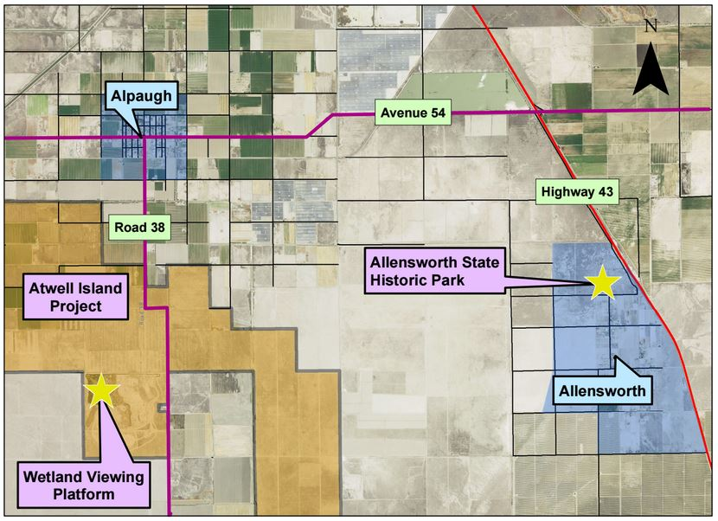

Considerations for determining a trail route:
- Connecting Allensworth to Alpaugh and linking the communities to Atwell Island and Colonel Allensworth State HistoricPark
- Collaborating and partnering with landowners, farmers, irrigation districts, and highspeed rail officials in obtaining permission and land easements for trail placement
- Utilizing existing infrastructure like levees and banks in order to prevent potential flooding and washout of the trail
- Maintaing the trail (long-term)
- Determining what materials will be used in trail construction
- Creating a trail that is in harmony with and accentuates the landscape
- Determining what types of recreational activities will the trail be used for
- Determining areas to be avoided in designing the trail route

Trails of Tulare County powerpoint presentation
Dezaraye Bagalayos – TBWP
In an effort to inspire and encourage creative visualization, Dezaraye presented a three-paneled demonstration board showcasing various trail systems that already exist in Tulare County. These trails included St. Johns River Parkway in Visalia, the Santa Fe Trail in Tulare, and the Bravo Lake Botanical Gardens trail in Woodlake.
The related power point presentation could not be shown at the meeting but is available here: morchella-and-me.tumblr.com/post/139934204816/aaa-trails-project-tuco-trails-powerppptx

Small group breakout session instructions
Denise Kadara – Allensworth Community Advocate
Denise instructed participants to break into four smaller groups and elect a note-taker/ group reporter. Each group was given a copy of the map presented by Rob Hansen and Larry Saslaw, a copy of the three-panel illustration by Doug Hansen, and a handout asking for input on three main ideas:
- The best possible location for the trail
- Activities the trail can be used for
- Benefits of having a nature trail connecting both communities to each other and local attractions

Large group discussion, consensus building, and artistic rendering of Trail vision/route
Denise Kadara – Community Advocate, Carole Combs – TBWP, and Lateef Kadara – Artist
The following are the compiled and summarized results from the small group session broken down by the three main topics on the handout.
LOCATION:
- The trail should connect the communities of Allensworth and Alpaugh as well as connect them to Atwell Island and Colonel Allensworth State Historic Park
- Trail heads could be located at Colonel Allensworth State Historic Park campground and Atwell Island viewing deck
- Connecting trail to spots that would encourage use
- Limiting trail entrances in order to increase safe usage and monitoring abilities
- Having the trail make a loop in order to offer several different possible trail experiences
- Limit the number of canals the trail would need to cross
- Take into consideration the high speed rail path and either avoid it or find a way to incorporate a portion of the trail into its path
- The trail should be meandering and scenic. No straight lines from point A to point B
ACTIVITIES:
- Walking, running, biking, roller skating/blading, skateboarding, dog walking, and horseback riding
- Benches, shaded areas, picnic tables along the trail for resting and viewing
- Exercise equipment along the trail and a natural obstacle course
- Citizen science: birding, monitoring and recording wildlife along the trail, environmental restoration education opportunities for students with trail maintenance and native plantings, STEM opportunities if trail passes the solar farm
- Community events including 5k runs and fun runs and holiday activities like Easter Egg hunts and Halloween parades with trick or treating along the way
- Education activities including the utilization of historical and natural trail signage
- Special days for horseback riding and ATVs
- Biodiversity nodes for learning about wildlife, native plants, and the ecosystem of the Tulare Lake bed
- Geocaching
- Hay rides
BENEFITS:
- Natural, cultural, and historical signs in English and Spanish along the trail that will help to educate residents and visitors and instill a sense of place and create regional identity
- Strengthening and creating partnerships between the communities, tribes, and other regional stakeholders
- Provide safer routes for traveling through the region
- Offer access to spaces that can provide a sense of serenity, peace, and the enjoyment of nature
- Outdoor educational activities for youth including opportunities to participate in trail creation and maintenance
- Walking field trips for students from around the region
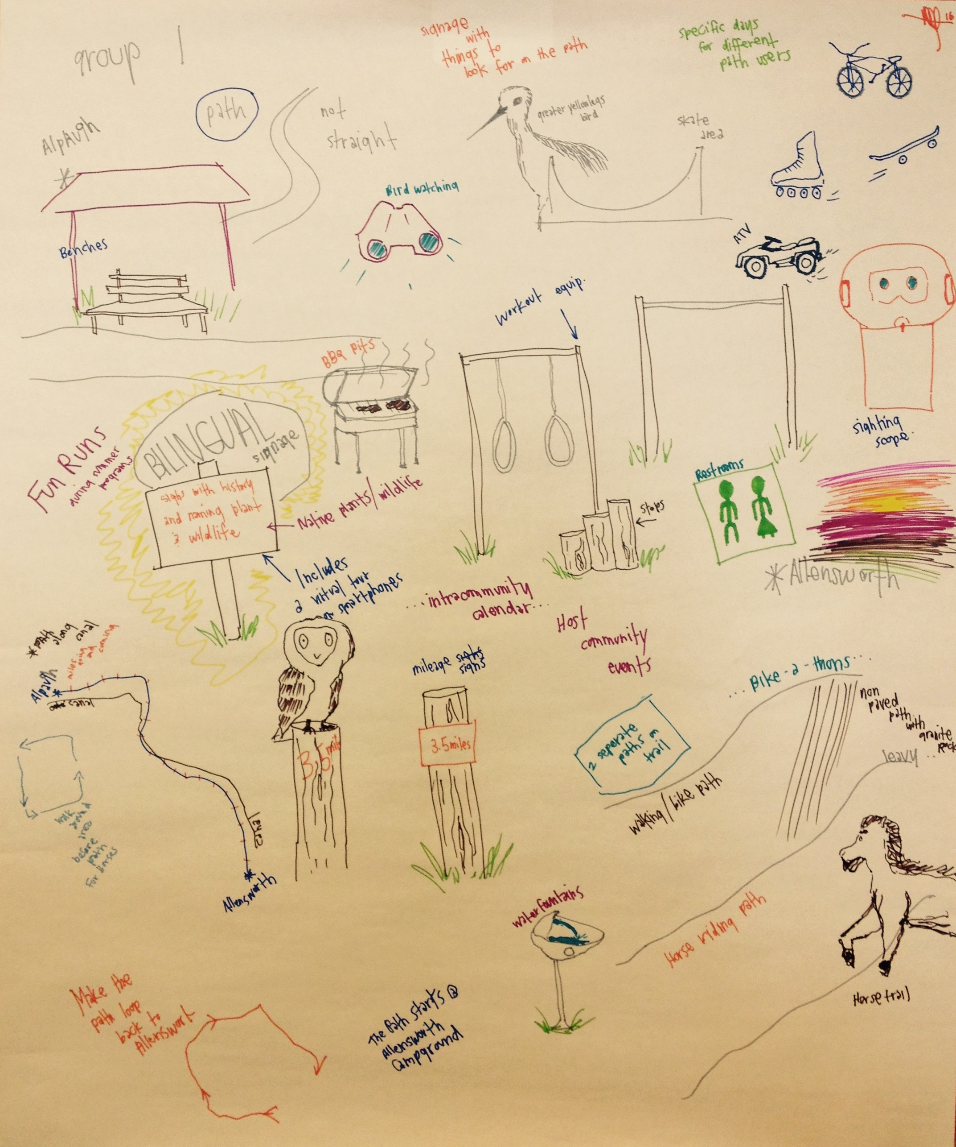
- Economic growth opportunities for both communities. As access to the area increases it will bring in more visitors creating opportunities for business growth that services tourists

*Artistic rendering of group discussion by Lateef Kadara
Wrap-up and next steps
Denise Kadara – Allensworth Community Advocate & Carole Combs – TBWP
This is a long term community project with demonstration value for the entire Valley. An important part of this project is the creation of an Allensworth-Alpaugh Intra-Community Advisory Council composed of community and tribal members, farmers, landowners, irrigation district and local agency representatives that will take the lead in moving the trails project forward as well as take action on implementing future projects that have community and regional benefits. The Central Valley Community Foundation has offered to hold an endowment on behalf of the Council -TBD.
Next Steps:
- Meet with farmers, landowners, irrigation districts, county representatives, and highspeed rail representatives to determine precise trail route and compile a list of needed easements, environmental reports, and permissions
- Build an Intra-Community Advisory Council starting with participants from this community meeting
- Prepare for the San Joaquin Valley Greenprint Phase 2 request for proposals (RFP) that will potentially supply the seed money for trail project planning
- Create and add to a list of funding sources for every step of the trail project implementation

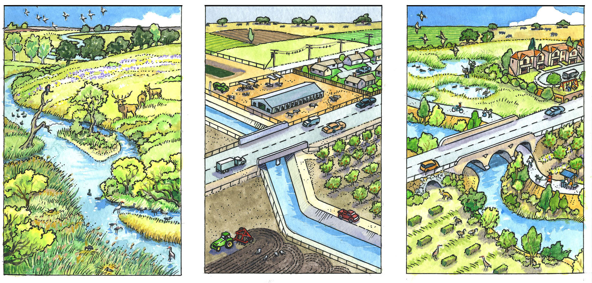

Community planning with nature in mind: Past, present, and future
Illustration by Doug Hansen

