Tulare Basin Watershed Connections Workgroup
Agenda
January 6th, 2016

Location: DWR South Central Region Office @ 3374 E. Shields Ave, Fresno
Time: 1:00 – 4:00
Call-in Number: 1-877-985-3104; Participant code: 4792363
https://resources.webex.com/resources/j.php?MTID=mc8a0ae78c95edeb96cdc3e37ae6f81f9
Meeting Agenda
1:00 - 1:10 Introductions and overview of agenda
1:10 - 1:20 Brief review of outcomes from last TB WCW meeting
1:20 - 1:50 Sierra Nevada tree die-off; lessons learned and future challenges (Roger Bales, UC Merced)
1:50 – 2:10 Results from the TB WCW project survey (Michelle Selmon, DWR)
Discussion about projects the group would like to pursue in 2016

2:10 – 2:30 Tulare Basin Wildlife Partners Conceptual Conservation Projects list (Rob Hansen, TBWP)

2:30 – 2:45 Break

2:45 – 3:10 Mill Flat Creek project (Bobby Kamansky, Kamansky Ecological Consulting)

3:10 – 3:35 Subgroup and partner updates

3:35 – 3:55 Open discussion about 2016 priorities and expectations

3:55 – 4:00 Wrap up/Next meeting – April 2016

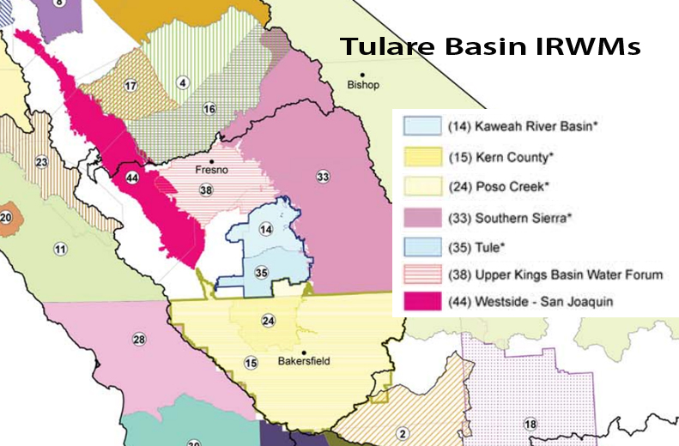

Tulare Basin Watershed Connections Workgroup

Goal Statement: To advance collaborative watershed planning and resource management in the Tulare Basin based on sound science and mutually identified needs for regional economic and ecological sustainability.

Ground Rules
- Participate and show respect for other members and their time
- Speak one at a time
- Share relevant information
- Be concise
- Express concerns and interests (not positions)
- Be solution-oriented
- Draw on each other’s experience
- Limit sidebar conversations
- Focus on what CAN be changed (not on what cannot be changed)
Subgroups
[Proposed] Purpose of Subgroups: Topic-based groups comprised of people with expertise and interest in developing strategies and implementing projects to address the challenges related to the topic; the subgroups meet and/or provide input to the broader working group as funding and partnership opportunities arise. There is substantial overlap and it is recognized that subgroup members should communicate with others as appropriate when planning a project or event.

- Funding
- Sustainable Groundwater and Surface Water
- Extreme Events and Climate Change Resilience
- Upper/Lower Watershed Connection: Education, Planning and Project Development
- Regional Landscape-scale Project Prioritization and Implementation
- Wetland and Wildlife Habitat Protection and Restoration
- Tribal Community Support for Addressing Water-related Challenges
- Disadvantaged Community Support for Water-Related Challenges

