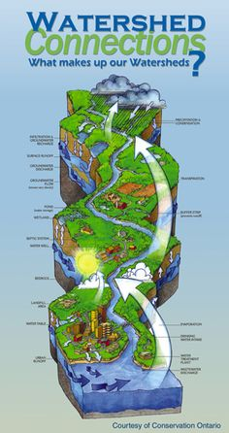
Tulare Basin
Watershed Connections
Goal: To advance collaborative watershed planning and resource management in the Tulare Basin based on sound science and mutually identified needs for regional economic and ecological sustainability

How can the Watershed Connections Workgroup partners assist GSAs?
- Data: our partners have information to help fill data gaps for more informed decision-making
- Expertise with collaborative regional approaches
- Assist with stakeholder engagement
- Project identification re: groundwater recharge
- Provide ideas on ways to consider and incorporate relevant information about sustainability connections to: DACs, ecosystems, water quality, watershed restoration and management, climate change
Sample Q/As
How can my GSA consider current and future wildlife needs as we create a GSP?
How can my GSA improve conjunctive management of surface and groundwater?
What data is available on: habitat corridors, recharge areas that could also serve as habitat or ag land, etc….

